Student research opportunity in East London, South Africa
The Eastern Cape Communication Forum (ECCF) in partnership with Walter Sisulu University (WSU) offers the opportunity for a student to conduct media related research in the Eastern Cape.
ECCF: The ECCF is a registered non-profit organisation (NPO) which aims at strengthening and professionalising local independent media in the Eastern Cape, primarily grassroots newspapers and radio stations, to ensure adequate citizen participation in the democratic processes of the country. It furthermore tries to combine theoretical teaching of WSU journalism students with practical interventions in the media sector.
ECCF provides training, workshops, and other forms of support to grassroots media and journalism students. It also includes a ‘Student News Agency’ (SNA) and catalyzes debates with students and media. ECCF is actively involved in the exchange of information and sharing of resources for the development of community media. Contacts have been established with local, national and international media support organisations. The German Development Service (DED) is the core funder of the ECCF.
Topic: The research should relate to media studies and the local independent media sector in particular. Local independent media refers to community radio stations registered with the national licensing authority as well as small commercial and community newspaper. In terms of print media, small commercial and community newspapers include all newspapers that do not belong to a state entity or a big media company.
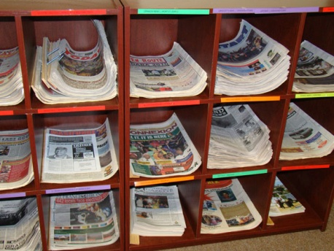
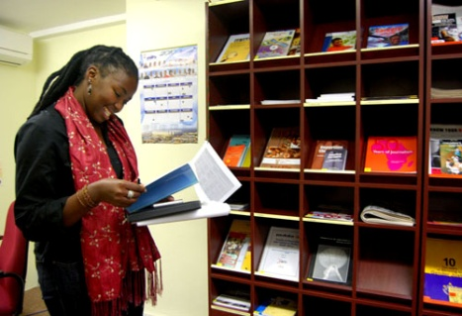
Workplace and facilities: ECCF and WSU offer a working space (office) within the facilities of the media hub. The media hub comprises of a training venue, a meeting room, offices and a resource centre. The resource centre (please see picture) comprises of material related to media with a particular focus on strengthening civil society and local democracy. It also consists of a unique library of local independent publications from the Eastern Cape (picture).
The working space is equipped with a desk, chair, cupboard, a telephone and internet access. Upon request a computer can be made available for the student.
East London: The media hub is located within the Department of Media Studies in the city centre of East London. East London offers all necessary amenities in the laid back atmosphere of a medium sized costal town. Accommodation is available in different price categories from local backpackers to granny flats. A car is recommended to get around town. For further research purposes several libraries are easily accessible.
Research assistance: ECCF and WSU will be able to assist the student in facilitating contact with representatives from local independent media organisations for interview opportunities and the conducting of surveys. It will further assist in providing contacts with all spheres of government, civil society organisations and relevant media support organisations. The student will be able to liaise directly with journalism students and other departments of WSU.
ECCF and WSU will assist in identifying relevant themes for postgraduate and any other studies, if necessary.
Research result: It is hoped that any research conducted would produce valuable information for ECCF and WSU to further develop their programmes of media support.
ECCF and WSU will not be able to avail any financial contribution to the study opportunity.
For more information on WSU please visit their website www.wsu.ac.za.
Should you require any further information or to share initial research ideas, please contact
Aniela Batschari
Communication Advisor

Tel. 0027-43-703 8591
Cell. 0027-82-546 4261
Email. ded@wsu.ac.za
Skype: anielabatschari

